Concept Art

We want to make our game in a Low poly style. This will not only be easier, but will express a strong focus on the textures, shapes and shading of our game. Cape Flats Chronicles will be set in a town in the western cape known as Mitchells plain. Known for its nitty gritty environment, with vast variety of crime such as, rape, murder, theft, gang violence.

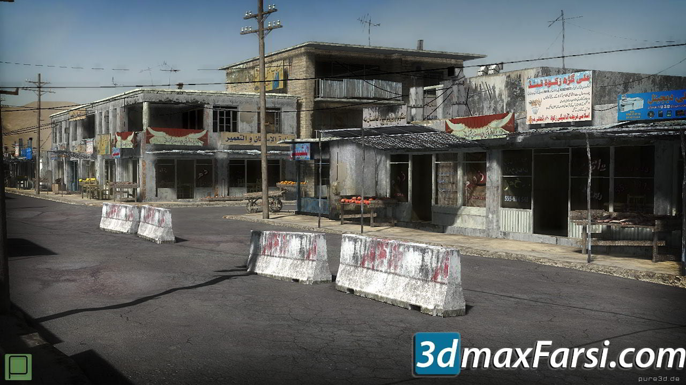

This is the type of setting we want to convey in our game. An environment that will display hardship.

Not all parts of our country is developed, economically to be exact so our game must show that shacks, damaged roads, and waste to name a few.

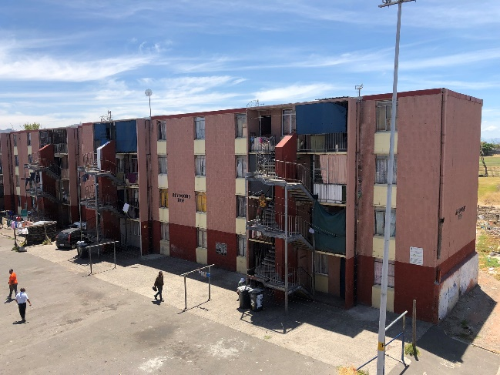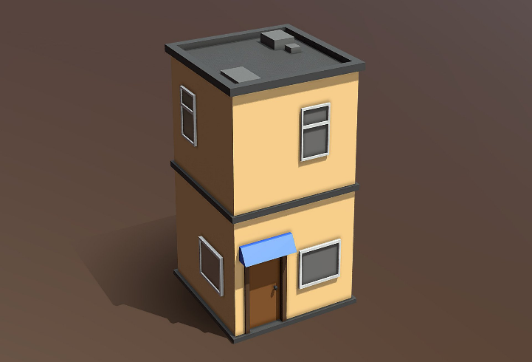

The image on the right is a picture of rental flats, that are highly associated with the history of the cape flats. That picture is inspiration of how our buildings will be in game and the picture on the right is how we want it to look, not necessarily how the picture looks, but in terms of the simple low poly art style and the use of strong distinguishable shapes and bright dirty colours.